Assignment 18.2

Problem Statement

1) Which route is generating the most revenue per year 2) What is the total amount spent by every user on air-travel per year 3) Considering age groups of < 20 , 20-35, 35 > ,Which age group is travelling the most every year.

Question 1 Solutions:

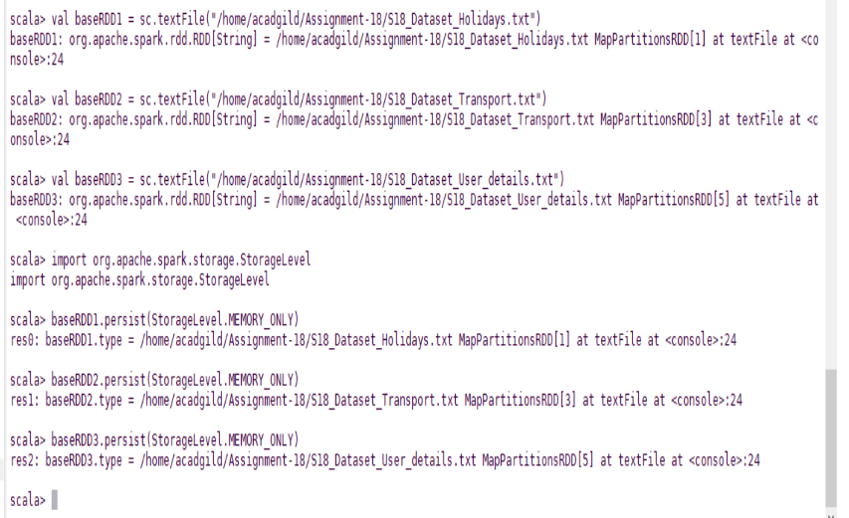



Question 2 Solutions:



Question 3_Solutions:

